Support vector machine (SVM) is a learning technique that performs well on sentiment classification. Which features do we have to use in order to classify texts using SVM? The most common answer is word frequencies, which is similar to what is done in Naïve Bayes. This means that we treat a text as a bag of words, and for every word that appears in that bag we have a feature. The value of that feature will be how frequent that word is in the text. The objective of a Linear SVC (Support Vector Classifier) is to fit to the data you provide, returning a "best fit" hyperplane that divides, or categorizes, your data. From there, after getting the hyperplane, you can then feed some features to your classifier to see what the "predicted" class is. There is a balance between SVC maximizing the margin of the hyperplane and minimizing the misclassification. In SVC, the latter is controlled with the hyperparameter CC, the penalty imposed on errors. C is a parameter of the SVC learner and is the penalty for misclassifying a data point. When C is small, the classifier is okay with misclassified data points (high bias but low variance). When C is large, the classifier is heavily penalized for misclassified data and therefore bends over backwards avoid any misclassified data points (low bias but high variance).



HYPERPARAMTERS TUNED:

* C: Regularization parameter.
* Gamma: if gamma='scale' (default) is passed then it uses 1 / (n_features * X.var()) as value of gamma, if ‘auto’, uses 1 / n_features.
* Kernel: Specifies the kernel type to be used in the algorithm. It must be one of ‘linear’, ‘poly’, ‘rbf’, ‘sigmoid’, ‘precomputed’ or a callable.

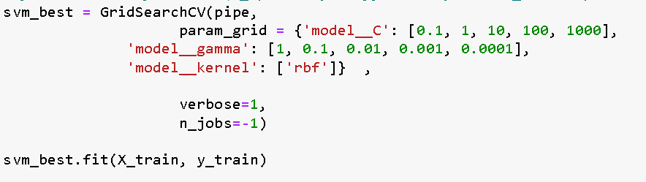

FINAL ACCURACY: 70.69%